

Reading in Reception

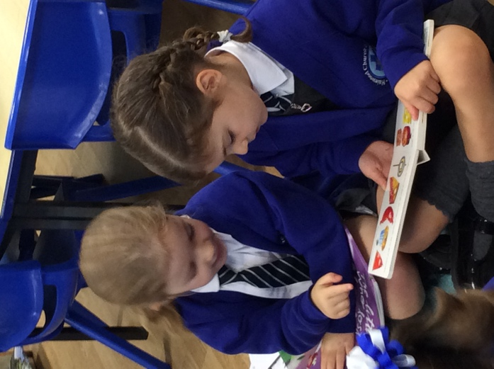

Information for Parents and Carers
2021

Introduction

Our Intent (Early Reading Policy)

- For children to be immersed in a literacy-rich environment
- For children to become confident and articulate communicators
- For children to develop a broad and high-level vocabulary
- For children to grow a love of literature through access to a broad range of high-quality texts
- For children to have the phonetic skills required to decode new words confidently
- For children to be able to draw on other cues to develop their understanding
- For children to read fluently with understanding
- For children to apply their reading skills in continuous provision and in across other areas of the curriculum in Year 1.

At Halewood CofE Primary Academy, we consider reading to be of the highest importance and the key to all aspects of learning, as it impacts on everything a child does.

In school your child will experience a wide range of reading opportunities, which include:

- Keyword reading
- Phonics – developing blending and segmenting skills and letter-sound correspondences
- Independent reading
- Enhancements within the provision – menus, lists, signs, challenges, environmental print
- Guided reading (led by a teacher or teaching assistant and a small group)
- Shared text work linked to our reading spine and stimulating texts in English sessions – fiction and non-fiction
- Comprehension
- Research using reference books, videos and ICT.

Some reading will take place during the English sessions (30 minutes daily) or guided sessions but equally, the children may have these opportunities during COOL time and at other times of the day.

This booklet is aimed to help you to help your child at home. Years of research show clearly that children are more likely to succeed in learning when their families actively support them. When you and other family members, older siblings even read with your child, help them with homework and participate in school or other learning activities, you give your child a tremendous advantage.

Implementation – How do we support your child in learning to read?

Daily Phonics
Our phonics scheme is Read Write Inc. The children have a daily 20-30 minutes phonics session. This begins with teaching initial Set 1 sounds. We teach a sound a day and progress from initial sounds to teach ch, sh, th, ng, nk, qu (digraphs) before moving on to the long vowel sounds ay, ee, igh, ow and oo in Set 2. By the summer term we begin to teach Set 3 sounds which include ay and ai and trigraphs such as air.

We send the new sounds we have taught home each week for the children to practise.

Word time
Alongside sound recognition and pronunciation we teach the children to blend and segment the words they read through word time sessions. There are 7 sets of word time words with Set 1 sounds.

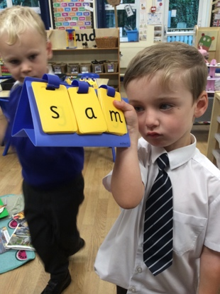

Guided reading
We use the phonetically decodable RWI books for our weekly guided reading sessions. The children work in pairs within groups of 4. Each session involves sound revision, green and red word reading practise and discussion to set the context of the book. One child acts as the teacher while the other child reads and then they swap over. They are encouraged to support each other if they struggle with a word. At the end of the book there are questions to check the children’s understanding. A copy of the guided book will be posted each week on Tapestry for further practise at home.

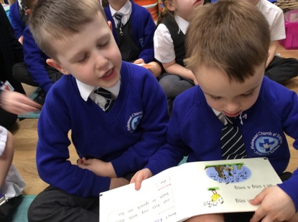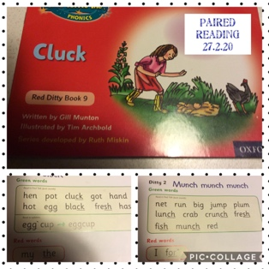

English sessions
Our English sessions include both fiction and non-fiction texts. High quality and topic related texts are selected either from the Reception core texts or to enhance particular themes. Often our topics are inspired by a new or particularly popular story book. We teach the children to recall events from the story, discuss the feelings and motives of characters, make predictions, make simple inferences and make connections between the texts they have read. We use the KS 1 VIPERS to teach key reading skills (included in the pack).

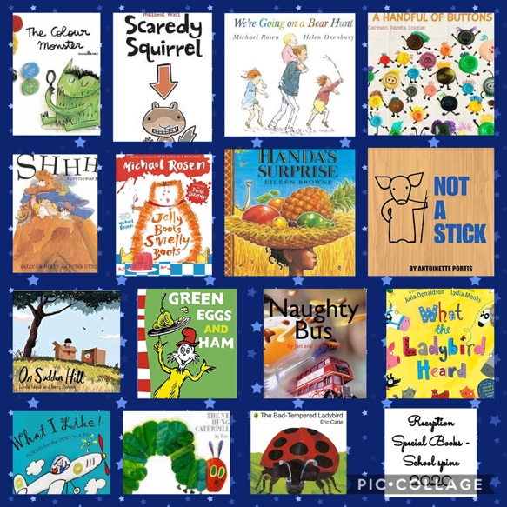

Individual reading
Each week your child will have a phonetically decodable book or text, plus the electronic copy of the guided text to read at home. We will also read this book with your child in school. Children who need more support may read this book several times a week in school.

Please read with your child a minimum of 4 times each week. If your child reads 5 times, they will be entered into Mr Smith’s Golden box for a prize draw at the end of each half term. Re-reading a text helps the children to develop fluency and pace as well as increasing their level of understanding.

Always encourage your child to stop if what they have read does not make sense and have another go. If your child is tired, read the text to them and ask them to just read the occasional word. Sometimes reading a word incorrectly, or replacing it with something really silly helps to show if your child is following as you read the text.

Reading records
All children in school are given a Reading Record Book. This needs to be brought to school every day with their book in their book bag. The staff at school will record in this book when they have read individually with your child. Guided reads will be recorded on Tapestry. We also ask parents to sign and date when you hear your child read at home. There is a space for you to comment too. Our 5 reads a week challenge is for home reading only.
High frequency/ common exception words
Early in the term we send home the 45 Reception high frequency words. When the children can read the 45 words, we celebrate by awarding them the title of Key Word Champion. Some children can read all 45 words by Christmas, others take longer. Keep practising these words alongside the home reading books please.

Later in the year we will increase these words to the first 100 high frequency words.

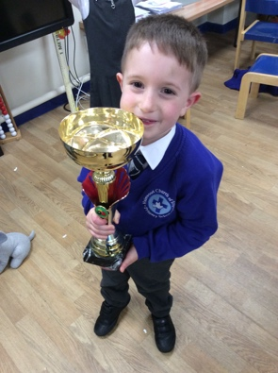
Example summary of Reading provision

Term | School | Home | HFW
Autumn 1 | Phonics - Set 1 RWI sounds | Twinkl – Comprehension tasks cvc Phase 2 1 per week  Word Time words 1-4 | 45 high frequency words
Autumn 2 | Phonics and guided reading  SET 1 RWI + Red Ditty Books | Ditties 1-28 home – 5 per week  Word Time words 5-7 | 45 high frequency words
Autumn 2 | Phonics and guided reading SET 1 RWI + Red Ditty Books | Red Book bag books – 2 per week + Twinkl Phase 2 60 minute decodable reads | 45 high frequency words

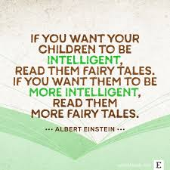

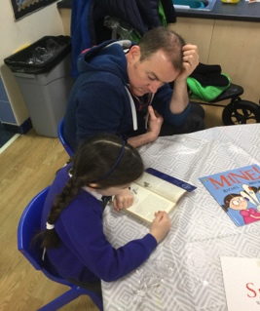
How can you help your child at home?

Please encourage your child to:

- Emerge your child in as much high-level, adventurous vocabulary as you can. They absolutely love ‘big words’ e.g. ravenous instead of hungry.
- Read as widely as possible and discuss the content of the book. Bedtime stories are the ideal opportunity to develop a love of stories and particular authors.
- Ask questions about the content, main characters/ setting of the story – refer to VIPERS.
- Discuss how the character is feeling and how they know this. Does the character, shout, stamp, cry, hide – look at facial expressions in the illustrations?
- Make predictions about what is going to happen next.
- Use correct book terminology (see glossary)
- Work out unfamiliar words by sounding them out/using clues from other words in the sentences to make a sensible guess/looking at the pictures for clues.
- Pay attention to punctuation and read for meaning.
- Stop and correct them if the reading does not make sense or they omit a word.

Example Questions:

- What do you predict the story is going to be about (looking at the front cover)?
- Who are the main characters?
- Where is the story set? (At home, the park, a forest)
- What do you think will happen next?
- Why did ________ say that?
- Why did they do that?
- Which part of the book did you like the most?
- What was the best/funniest/ saddest part of the story?
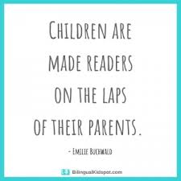
- What does the picture tell you?

Reading skills your child needs to develop:
Vocabulary
Inference
Prediction
Explanation
Recall
Summarise

- Holding a book – the correct way up
- Locating print on the page and discriminating between text and illustrations
- Locate where to start reading at the top left and read left to right/ top to bottom/ front to back of the book for fiction.
- Begin to navigate non-fiction with labels and captions.
- Notice spaces between words, practise one-to-one word correspondence (pointing to each word as they read).
- Identify speech bubbles, full stops, question marks, exclamation marks and large print.
- Identify letters and use knowledge of sounds to sound out and decode words.
- Identify some sight vocabulary – reading words instantly.
- Identify some sounds within a word. E.g. know the first and last sound, spot words within words.
- Understand the terminology of ‘letter,’ ‘word,’ ‘phrase,’ ‘sentence.’

Glossary of terms

Author – the person who writes a text.

Blurb – a summary of the text found on the back of a book.

Character – a person or animal in a story, play or film.

Cvc/cvcc/ccvc – A cvc word is a word that is made up from a consonant, vowel then a consonant. A cvcc is made up from a consonant, vowel, consonant, consonant and a ccvc word is made up from two consonants, a vowel and a consonant.

Decoding – is the process of seeing written words on a page and being able to say them out loud.

Digraph – two letters that make one sound. Digraphs can be made up from vowels or consonants.

Exclamation mark - is a punctuation mark which looks like a straight line with a dot underneath it. It is used to show that an exclamation, an interjection or a statement sentence has finished.

Fiction – writing that describes imaginary events and people – not real life.

Full stop – a punctuation mark used at the end of a sentence. Marks a pause in time.

Grapheme - is a written symbol that represents a sound (a phoneme). This can be a single letter, or could be a sequence of letters (ai, sh, igh, tch, for example).

Illustrator – a person who draw or creates pictures for books, magazines, advertising etc

Letter sound - is literally the sound we make when we are reading a written letter of the alphabet.

Title – the name of a book.

Any text that is not a story is non-fiction. Non-fiction texts studied in Reception include instruction texts, recounts, information texts, lists.

A phoneme is the smallest unit of sound.

Phonics – teaching people to read by correlating sounds with letter symbols.

Phrase - A phrase is a small group of words that does not contain a verb.

Predict - to say or estimate what might happen in the future or will be a consequence of something.

Question - is a type of sentence that we ask or write to gain further information from a person or people responding.

Rhyme is the repetition of similar sounds in words, usually at the end of lines in poems and songs

A sentence is one word or a group of words that makes sense by itself (a grammatical unit). Sentences begin with a capital letter and end with a full stop, a question mark or an exclamation point. Sentences usually contain a subject (doing something) and a verb (what is being done).

Setting – the place or surroundings where a story takes place.

A syllable is a single, unbroken sound of a spoken (or written) word. Syllables are sometimes called the ‘beats’ of a word.

A trigraph is a single sound that is represented by three letters, for example tch, igh in fight or ear in bear.

The alphabet is made up of 26 letters, 5 of which are vowels (a, e, i, o, u) and the rest of which are consonants. A vowel is a sound that is made by allowing breath to flow out of the mouth, without closing any part of the mouth or throat.

For further information see also:
Book Trust - Guidance for parents in packs
KS 1 VIPERS – in packs
Read Write Inc - https://home.oxfordowl.co.uk/reading/reading-schemes-oxford-levels/read-write-inc-phonics-guide/

