

Reading in LKS2

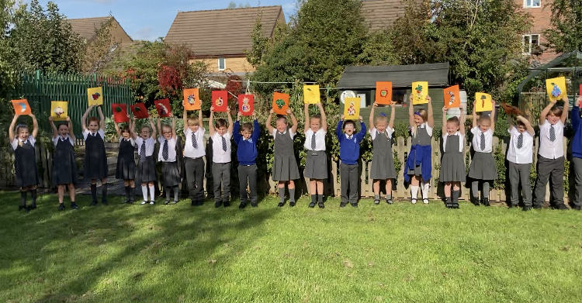

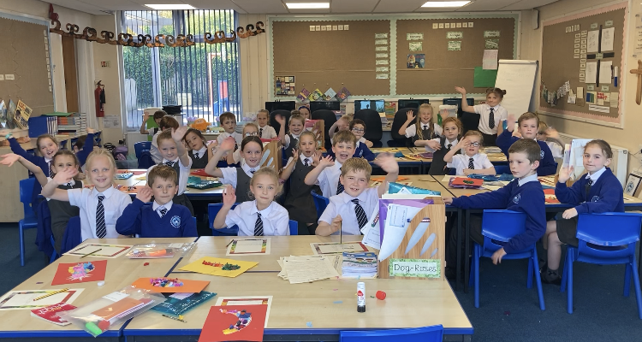

Information for Parents and Carers
2021
Introduction

Our Intent (Reading Policy)

- To promote a culture where children share our passion for and love of reading.
- For all children to be fluent, proficient and confident readers prepared for adult life.
- For all children to understand high-level vocabulary and be articulate speakers.
- For children to be able to demonstrate their understanding, share their views on what they have read and develop the ability to compare texts and express opinions about them.
- For children to experience a broad range of high-quality literature (including classics, poetry and information texts).
- To ignite the children’s imaginations and bring literature to life.

At Halewood CofE Primary Academy, we consider reading to be of the highest importance and the key to all aspects of learning, as it impacts on everything a child does.

In school your child will experience a wide range of reading opportunities, which include:

- Independent reading as an opportunity to read their accelerated reader book
- Independent reading as an opportunity to read for pleasure
- Whole Class Reading Sessions
- Story Time where the teacher will read a class text to the class to encourage reading for pleasure
- English sessions when we immerse into a particular genre
- Regular opportunities to read in non-core subjects to enhance children’s knowledge and fact recall
- Opportunity to read to younger children, if in the ‘Book Squad’
- Research using reference books, videos and ICT

This booklet is aimed to help you to help your child at home. Years of research show clearly that children are more likely to succeed in learning when their families actively support them. When you and other family members, older siblings even read with your child, help them with homework and participate in school or other learning activities, you give your child a tremendous advantage.

Implementation – How do we support your child in learning to read?

Daily Accelerated Reader
Every day children are given 20-30 minutes to read their accelerated reader book. As children read their book, they are encouraged to keep a mind map/story map of what they have read. This supports children with picking out the key information from the story. Children also take the same book home to read to parents and family members. Once the book is complete, children are able to use class ipads to access the ‘Accelerated Reader’ website. On the website, they complete a quiz on the book they have read. This quiz checks the child’s understanding of what they have read. Teachers closely monitor children’s results and after scoring 80% or more at least 3 times the teacher will move the child up to an appropriate ZPD. We do encourage children to read a range and breadth of books before moving onto the next level.

Daily Whole Class Reading Sessions
During the school day, every class has a 20-30 minute reading session. This gives children the opportunity to explore a variety of texts over the course of the academic year. They will have the opportunity to read extracts from classic novels, fiction, non-fiction and poems. This is an excellent opportunity for children to develop their reading out loud skills. Over the course of the week all children will be able to have read out loud to the class. After a text or extract has been read, children will focus on the different reading skills (VIPERS: vocabulary, inference, prediction, explaining language, retrieval and summarising), answering given questions. Additionally, some of the texts may link to learning across the non-core curriculum. This ensures our children are learning key specific vocabulary and are reading for a range of purposes.

Reading Pace
Every half term, children will be given an age expected text to read. Children will record how many words they have been able to read in 1 minute. This activity is very useful to ensure our children are reading at a steady and appropriate pace. If children are not at the expected pace interventions and support with decoding and basic phonics can be put into place.

Reading in the Non-Core Curriculum
Our RAISE non-core curriculum has been carefully designed and sequenced ensuring that reading is a key part. In many non-core sessions, high quality texts will be shared with the children to make sure they can use their reading knowledge to learn key facts.

English sessions
Our English sessions are a fantastic way to include opportunities for reading. At the start of every English topic we immerse our children by reading and exploring high quality examples of the chosen genre. These sessions include a lot of discussion about the text and can include many of the VIPER skills as children gain an understanding of the style of writing they will be moving towards. Each English unit has a carefully selected modelled text, which uses high-level vocabulary to challenge and inspire our children.

Reading Displays
All classrooms have a reading display, which clearly shows the VIPERS skills. The display share example questions for the children to gain an understanding of the sort of questions they will be asked. Any new high-level vocabulary is displayed which supports our children in having rich vocabulary.

Individual reading at home
Your child will have a book they have chosen from the school library, which follows our ‘Accelerated Reader’ programme.

Please read with your child a minimum of 4 times each week. If your child reads 5 times, they will be entered into Mr Smith’s Golden box for a prize draw every Monday morning. Re-reading a text helps the children to develop fluency and pace as well as increasing their level of understanding. We have a school reading trophy which will go to the class with the highest number of children who have read 5 times or more at home in the week. Discussion around the content of the text is crucial to support your child’s reading progress and to help their understanding and develop their vocabulary.

Always encourage your child to stop if what they have read does not make sense and have another go.

Reading records
All children in school are given a Reading Record Book. This needs to be brought to school every day with their book, in their book bag. The staff at school will record in this book when they have read individually with your child. We also ask parents to sign and date when you hear your child read at home. There is a space for you to comment too. Our 5 reads a week challenge is for home reading only.

Year 3/4 Common Exception Words
Children will have to be able to read and write these words by the end of Year 4. Each week in class we will focus on a couple of them. Please support your child at home with this and help them to learn the spellings. It is important that your child can recall the correct spelling of these words over a long period of time and not just the week of learning them. Additionally, it is paramount that your child can apply their spelling into their writing. There are many ways you can support your child with spelling at home including: games, songs and rhymes.

Whole Class Text/ Story Time
Every class has a whole class text, which the teacher will read to the children at various points through the week. This is an opportunity for children to be completely engrossed in the book and enjoy listening to a story. It is also a good way for teachers to model to children all of the important skills involved with reading out loud to an audience. The class texts are carefully selected and touch on a range of different subjects and topics including: history, PSHE, English units, diversity and culture.

Example Summary of Reading provision

Term | School | Home
Autumn | . Year 3/4 Common Exception Words  . Learn spelling patterns and rules.  . Spelling Shed  . Weekly spelling quiz to closely monitor children’s spelling ability.  . Some children will read 1:1 daily with an adult if we feel this will benefit the child.  . Daily whole class reading sessions focussed on the VIPER skills.  . Class Texts for ‘Story Time’ to encourage reading for pleasure.  . Reading pace activities to support children read at the expected pace.  . Reading comprehension booklets.  . Motivate our children to read by having the whole school reading trophy, which is given to a class every week for the most x5 readers.  . Reading in Non-core subjects with carefully selected texts to enhance our children’s reading skills and knowledge. | . Read ‘Accelerated Reader’ book.  . Parents to listen to and read with their child at least 4 times per week. Every time your child reads please sign their reading record book.  . When listening to children read use the VIPER skills as a focus for discussions around the text.
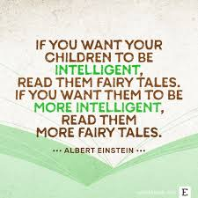

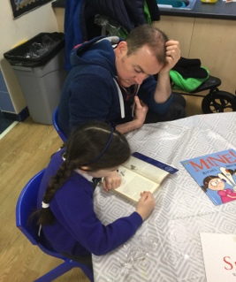
How can you help your child at home?

Please encourage your child to:

- Emerge your child in as much high-level, adventurous vocabulary as you can. They absolutely love ‘big words’ e.g. ravenous instead of hungry.
- Read as widely as possible and discuss the content of the book. Bedtime stories are the ideal opportunity to develop a love of stories and particular authors.
- Ask questions about the content, main characters/ setting of the story – refer to VIPERS.
- Discuss how the character is feeling and how they know this. Does the character, shout, stamp, cry, hide – look at facial expressions and body language in the illustrations?
- Make predictions about what is going to happen next.
- Use correct book terminology (see glossary)
- Work out unfamiliar words by sounding them out/using clues from other words in the sentences to make a sensible guess/looking at the pictures for clues.
- Pay attention to punctuation and read for meaning.
- Stop and correct them if the reading does not make sense or they omit a word.

Example Questions:

- What do you predict the story is going to be about (looking at the front cover)?
- Who are the main characters?
- Where is the story set? (At home, the park, a forest)
- What do you think will happen next?
- Why did ________ say that?
- Why did they do that?
- Which part of the book did you like the most?
- What was the best/funniest/ saddest part of the story?
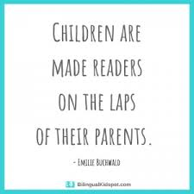
- What does the picture tell you?
- How does the line ________ effect the reader?
- Why did the author choose to use ________ this word/phrase?

Reading skills your child needs to develop:
Vocabulary
Inference
Prediction
Explanation
Recall
Summarise

Glossary of terms

Author – the person who writes a text.

Blurb – a summary of the text found on the back of a book.

Character – a person or animal in a story, play or film.

Cvc/cvcc/ccvc – A cvc word is a word that is made up from a consonant, vowel then a consonant. A cvcc is made up from a consonant, vowel, consonant, consonant and a ccvc word is made up from two consonants, a vowel and a consonant.

Decoding – is the process of seeing written words on a page and being able to say them out loud.

Digraph – two letters that make one sound. Digraphs can be made up from vowels or consonants.

Exclamation mark - is a punctuation mark which looks like a straight line with a dot underneath it. It is used to show that an exclamation, an interjection or a statement sentence has finished.

Fiction – writing that describes imaginary events and people – not real life.

Full stop – a punctuation mark used at the end of a sentence. Marks a pause in time.

Grapheme - is a written symbol that represents a sound (a phoneme). This can be a single letter, or could be a sequence of letters (ai, sh, igh, tch, for example).

Illustrator – a person who draw or creates pictures for books, magazines, advertising etc

Letter sound - is literally the sound we make when we are reading a written letter of the alphabet.

Title – the name of a book.

Non- Fiction - Any text that is not a story is non-fiction. Non-fiction texts studied in UKS2 include instruction texts, recounts, biographies, balance arguments and diary entries.

Phrase - A phrase is a small group of words that does not contain a verb.

Predict - to say or estimate what might happen in the future or will be a consequence of something.

Question - is a type of sentence that we ask or write to gain further information from a person or people responding.

Rhyme is the repetition of similar sounds in words, usually at the end of lines in poems and songs

A sentence is one word or a group of words that makes sense by itself (a grammatical unit). Sentences begin with a capital letter and end with a full stop, a question mark or an exclamation point. Sentences usually contain a subject (doing something) and a verb (what is being done).

Setting – the place or surroundings where a story takes place.

A syllable is a single, unbroken sound of a spoken (or written) word. Syllables are sometimes called the ‘beats’ of a word.

The alphabet is made up of 26 letters, 5 of which are vowels (a, e, i, o, u) and the rest of which are consonants. A vowel is a sound that is made by allowing breath to flow out of the mouth, without closing any part of the mouth or throat.

For further information see also:
KS 2 VIPERS – in packs
Read Write Inc - https://home.oxfordowl.co.uk/reading/reading-schemes-oxford-levels/read-write-inc-phonics-guide/

