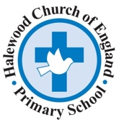

Halewood Church of England Primary Academy Reading Spine

Rationale:

The purpose of our school reading spine is to immerse our children in a range of high-quality texts from differing genres in order to ignite their imaginations, develop their knowledge and inspire a love of literature and reading.

Our texts have been chosen with reference to Pie Corbett’s trusted spine and also by watching recommendations on social media and Love Reading for Kids. This ensures that our texts are age specific.

Our spine includes both fiction and non-fiction and texts by BAME authors or characters from different cultures and ethnic groups. It also contains our Ready Steady Write Vehicle texts and No Outsiders curriculum texts.

Some of our texts will be read to the children for pleasure, while others will be read as part of our whole class reading sessions developing specific reading skills and or to develop the wider curriculum, e.g. historical texts.

Our spine is not set in stone and will be reviewed annually to ensure it meets our school demographic, children’s interests and is the most engaging that it can be.

The reading spine will be displayed in each classroom so that children are familiar with the chosen texts.

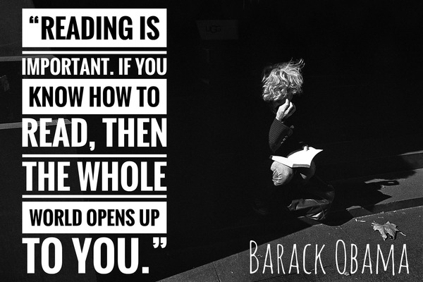

Reception Reading Spine | Text | Genre | Purpose
Reception Reading Spine | The Colour Monster  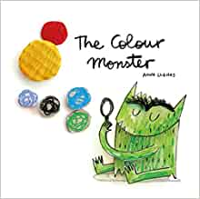  A. Llenas | Fiction | PSHE - feelings settling in English unit
Reception Reading Spine | Ruby’s Worry  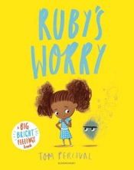  Tom Percival | Fiction | PSHE -feelings Storytime
Reception Reading Spine | Sharing a Shell  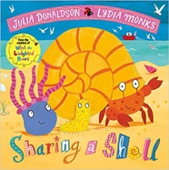  J. Donaldson | Rhyming story -poetry | PSHE - sharing settling in English unit
Reception Reading Spine | Welly boots  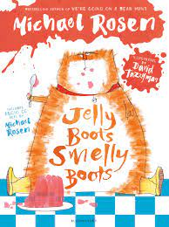  M. Rosen | Poetry | Storytime
Reception Reading Spine | Little Tree  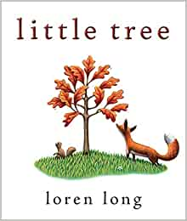  Loren Long | Fiction | Autumn unit
Reception Reading Spine | The Dot  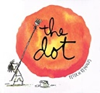  Peter H Reynolds | Fiction | English Unit – Make your mark…
Reception Reading Spine | The Leaf Thief  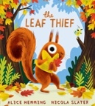  A. Hemming | Fiction | Storytime
Reception Reading Spine | Let’s Celebrate 5 Days of  Diwali  A. Chakraborty | Fiction | Diwali Topic
Reception Reading Spine | The Gruffalo  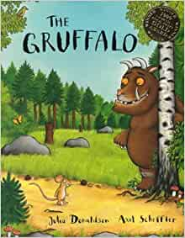  J. Donaldson | Fiction | Storytime
Reception Reading Spine | We’re going on a Bear Hunt  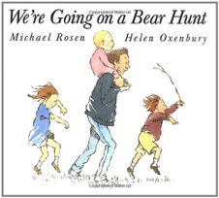  M. Rosen | Classic Fiction | Storytime
Reception Reading Spine | Six Dinner Sid  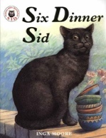  Inga Moore | Modern classic | Storytime
Reception Reading Spine | Rosie’s Walk  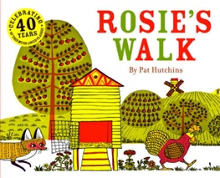  Pat Hutchins | Modern classic | Maths – positional language
Reception Reading Spine | Handa’s Surprise  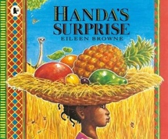  E. Browne | Fiction – stories from other cultures | Diversity unit – African animals
Reception Reading Spine | A Handful of Buttons  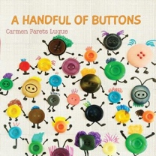  C Paret-Luque | Fiction | PSHE link – diversity unit
Reception Reading Spine | The Sunflower Sisters  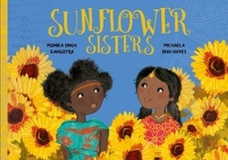  Monika Singh Gangotra and Michaela Dias-Hayes | Fiction | Science – growth Understanding the world
Reception Reading Spine | The Proudest Blue  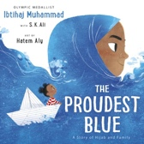  Ibtihaj Muhammad | Fiction | Storytime – Diversity
Reception Reading Spine | The Gingerbread Man  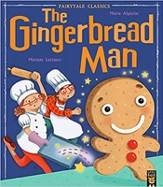  Miriam Lotimer | Traditional Tale | Storytime
Reception Reading Spine | The Princess and the Frog  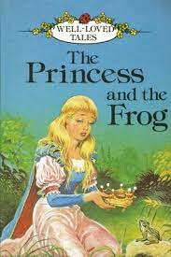 | Traditional Tale | Understanding the World – Science Life cycles
Reception Reading Spine | Naughty Bus  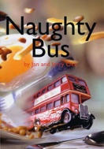  Jan and Jerry Oke | Modern Fiction | Storytime
Reception Reading Spine | How do Flowers Grow?  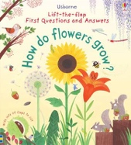  Katie Downes | Non-Fiction | Science Growth – Understanding of the World
Reception Reading Spine | What I Like  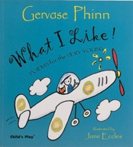  Gervase Phinn | Poetry | Storytime
Reception Reading Spine | The Very Hungry Caterpillar 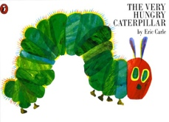  Eric Carle  The Bad-Tempered Ladybird  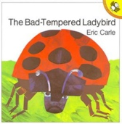  Eric Carle | Classic Fiction  Stories by the same author | Minibeasts topic – scientific/understanding of the world
Reception Reading Spine | Pishu the Panda  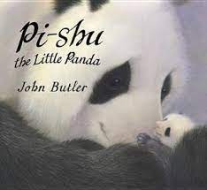  John Butler | Fiction | Environment – China – bamboo forests
 | Please Help Planet Earth  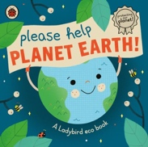  Ladybird | Non-fiction | Storytime - Environment
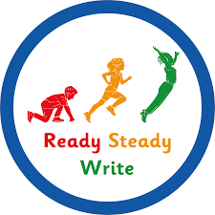 | 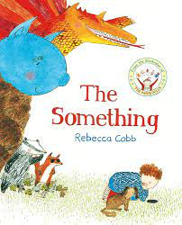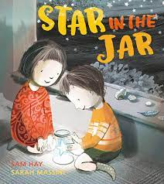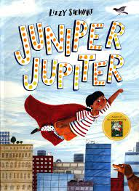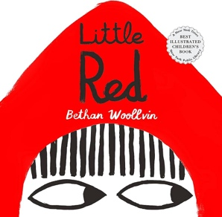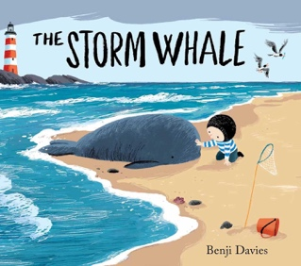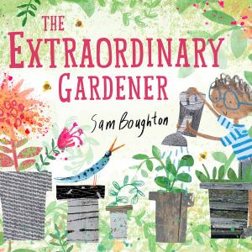
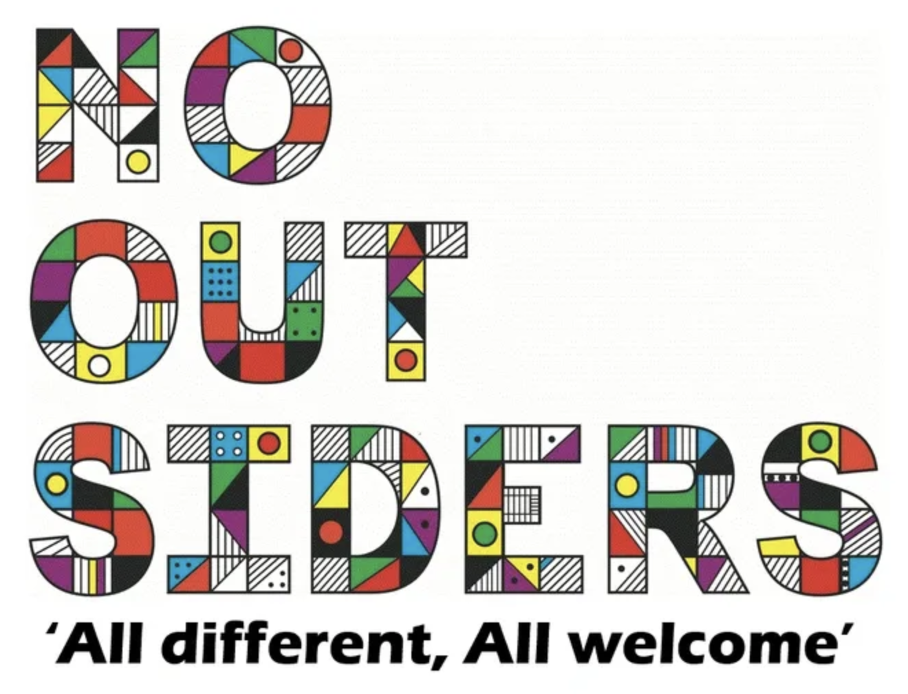 | You Choose  Red Rockets and Rainbow Jelly  Hello. Hello  The Family Book  Mommy, Mama and Me  Blue Chameleon

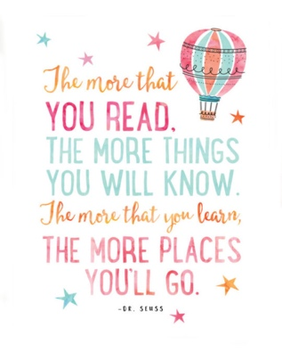

Year One Reading Spine | Text | Genre | Purpose
Year One Reading Spine | The Giraffe the Pelly and Me  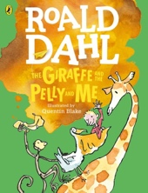  Roald Dahl | Classic Fiction | Storytime
Year One Reading Spine | The Black Book of Colours  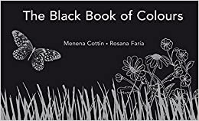  Menena Cottin and Rosana Faria | Fiction | Storytime
Year One Reading Spine | The Magic Box  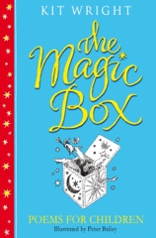  K. Wright | Poetry
Year One Reading Spine | Not now Bernard  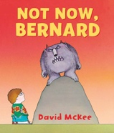  D. McKee | Classic Fiction | Storytime
Year One Reading Spine | The Ghanaian Goldilocks  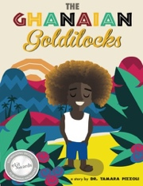  Dr Tamara Pizzoli | Fiction
Year One Reading Spine | Man on the Moon  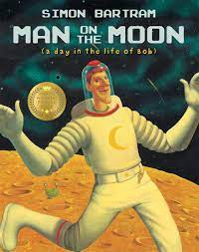  S. Bartram | Fiction | History link – Important people -Space
Year One Reading Spine | Monkey Puzzle  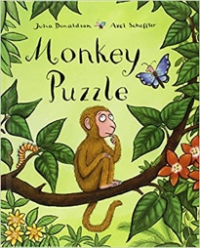  J. Donaldson Axel Scheffler | Fiction | Storytime
Year One Reading Spine | Avocado Baby  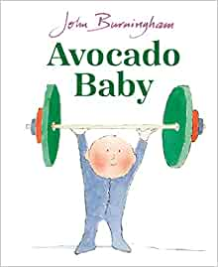  J. Burningham | Fiction | Storytime
Year One Reading Spine | The Princess and the Pea  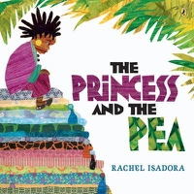  Rachel Isadora | Fiction | Traditional tales from other culture
Year One Reading Spine | The Tiny Seed  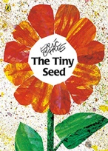  E. Carle | Fiction
Year One Reading Spine | Twinkle Twinkle Chocolate Bar  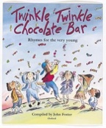  John Foster | Poetry
Year One Reading Spine | Lost and Found  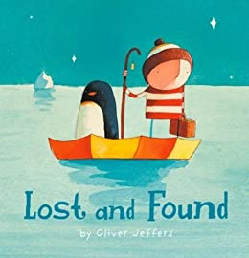  Oliver Jeffers | Fiction | Storytime
 | 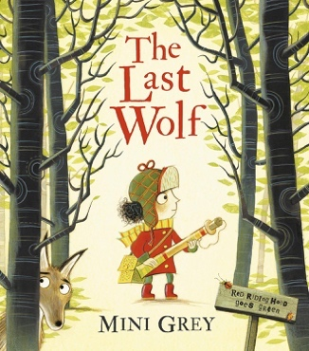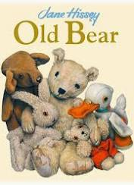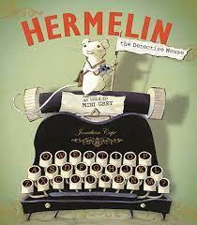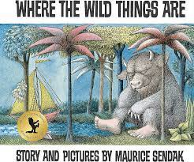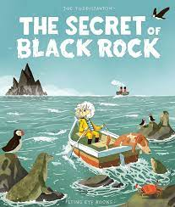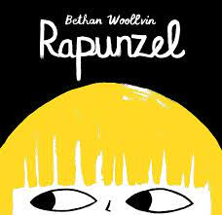
Elmer
Going to the Volcano
Want to play Trucks?
Hair, It’s a Family Affair!
My World, Your World
Errol’s Garden

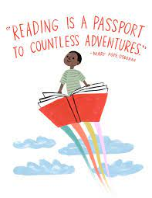

Year Two Reading Spine | Text | Genre | Purpose
Year Two Reading Spine | Dogger  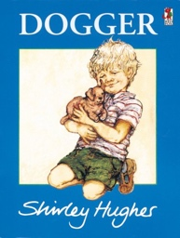  S. Hughes | Classic fiction
Year Two Reading Spine | We’re all wonders  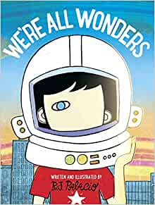  R J Palacio | Modern fiction | PSHE link
Year Two Reading Spine | Gus the Asparagus  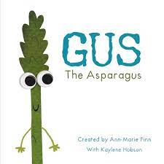  Ann-Marie Finn | Modern fiction | PSHE link
Year Two Reading Spine | Great women who changed the world  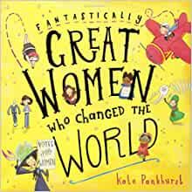  Kate Pankhurst | Biographies | Historical
Year Two Reading Spine | Big Blue Whale  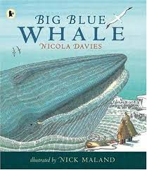  Nicola Davies | Non-fiction
Year Two Reading Spine | Crazy Mayonnaisy Mum  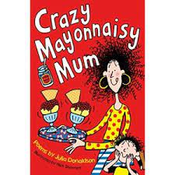  J. Donaldson  A First Poetry Book  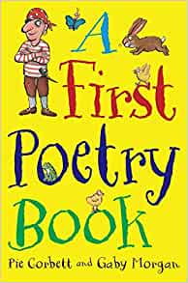  Pie Corbett | Poetry
Year Two Reading Spine | The Owl who was Afraid of the Dark  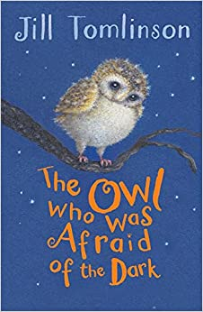  J. Tomlinson | Fiction | Storytime
Year Two Reading Spine | The Boy who Grew Dragons  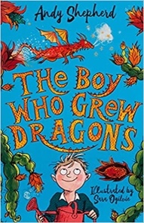  A. Shepherd | Fiction | Storytime
Year Two Reading Spine | The Great Fire of London  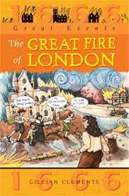  G. Clements | Historical fiction | History link
 | Lucy’s Rabbit  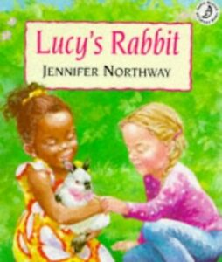  J. Northway | Fiction | Storytime
 | Where my Wellies Take me  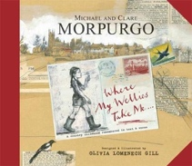  M. Morpurgo | Poetry
 | Peter Rabbit collection  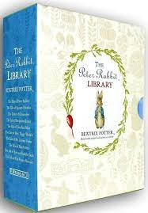  B. Potter | Classic fiction | Storytime
 | Into the Forest  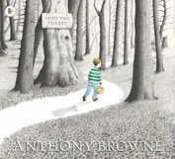  A. Browne | Fiction
 | The Tear Thief  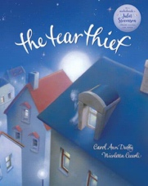  Carol Ann Duffy | Fiction
 | Watch Me Grow: Panda  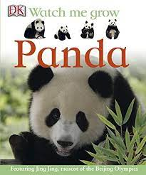  Fleur Star | Non-Fiction
 | Cinnamon  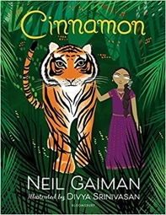  Neil Gaiman | Fable | Storytime
 | Heard it in the Playground  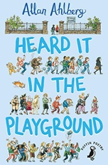  Allan Ahlberg  I am the seed that grew the tree  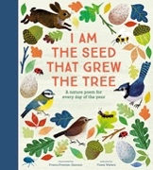  Fiona Waters | Poetry
 | The Enchanted Wood  (The Magic faraway tree)  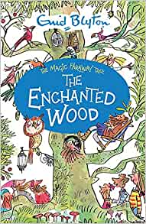  Enid Blyton | Classic Fiction
 | 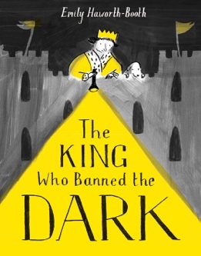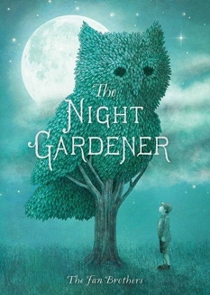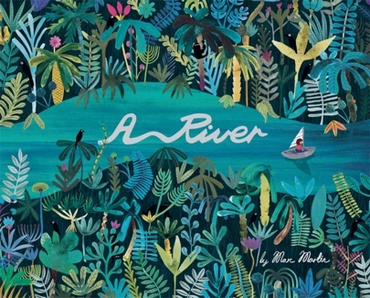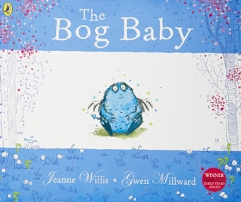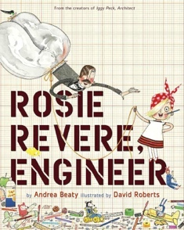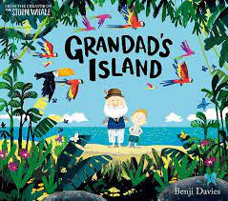
Can I Join Your Club?
How to be a Lion
The Great Big Book of Families
Amazing
What the Jackdaw Saw
All are Welcome

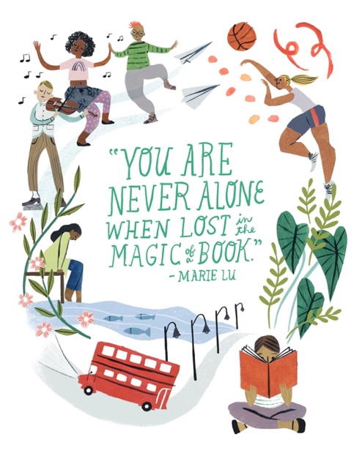

Year Three Reading Spine | Text | Genre | Purpose
Year Three Reading Spine | Amazing Grace  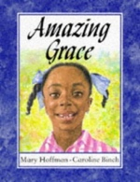  Mary Hoffman | Fiction
Year Three Reading Spine | The Firebird  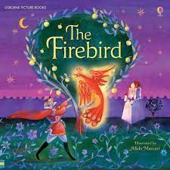 | Fiction | Whole class reading
Year Three Reading Spine | See Inside Your Body  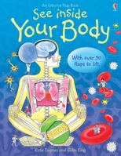  Katie Daynes | Non-FIction
Year Three Reading Spine | The Door  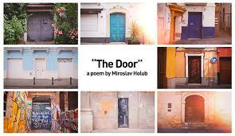  Miroslav Holub | Poetry
Year Three Reading Spine | The Lion, the Witch and the Wardrobe  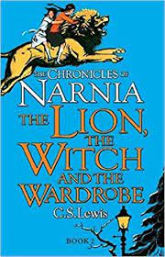  C.S. Lewis | Classic Fiction | Storytime
Year Three Reading Spine | Varjak Paw  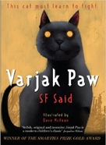  D. McKean | Fiction
Year Three Reading Spine | I am not a Label  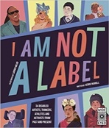  Cerrie Burnell | Fiction | Diversity
Year Three Reading Spine | Gran Can You Nap?  Jack Ousby | Poetry
Year Three Reading Spine | The World’s Greatest Space Cadet  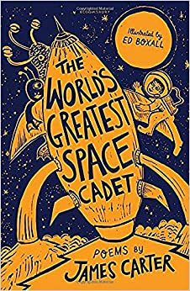  James Carter | Poetry
Year Three Reading Spine | James and the Giant Peach  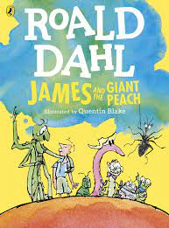  R. Dahl | Classic fiction | Storytime
Year Three Reading Spine | Tom’s Sausage Lion  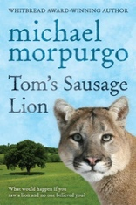  M. Morpurgo | Fiction
Year Three Reading Spine | The Street Beneath my Feet  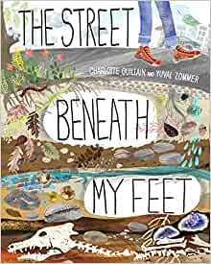  C. Guillain | Non-Fiction | Information Science link - Rocks
Year Three Reading Spine | The River  Valerie Bloom | Poetry
Year Three Reading Spine | The Twits Play for Children: Dialogues and Plays  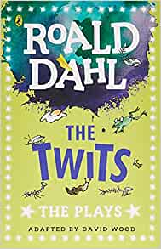  R. Dahl | Play
 | 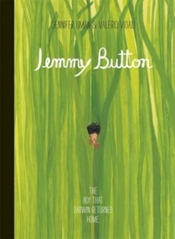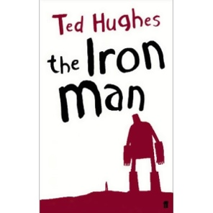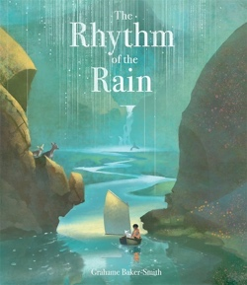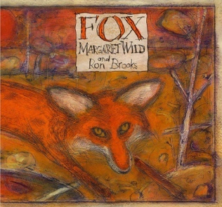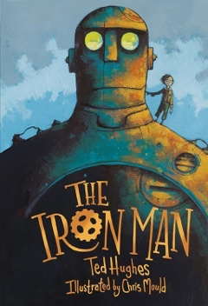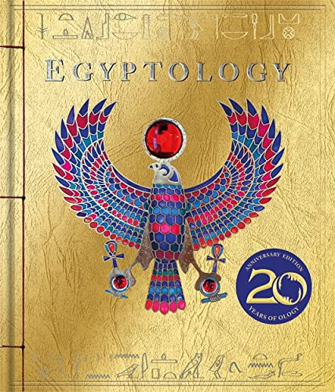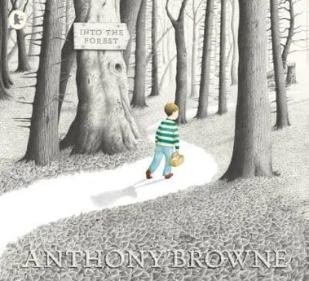
This is Our House
We Are All Wonders
Beegu
The Truth About Old People
The Hueys in The New Jumper
Planet Omar Accidental Trouble Magnet

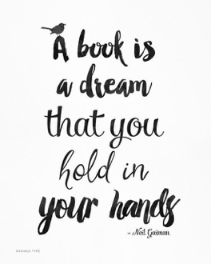

Year Four Reading Spine | Text | Genre | Purpose
Year Four Reading Spine | The Butterfly Lion  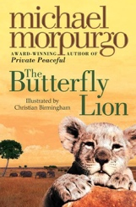  M. Morpurgo | FIction | Whole class reading
Year Four Reading Spine | Wind Poems  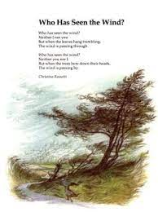  Christina Rosetti | Poetry
Year Four Reading Spine | Why the Whales Came  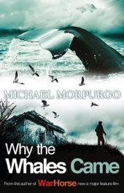  M. Morpurgo | Fiction | Whole class reading
Year Four Reading Spine | Escape from Pompeii  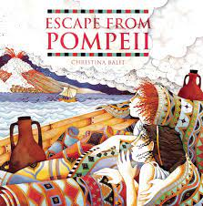  C. Balitt | Historical fiction | Stories from Historical Settings  Whole class reading
Year Four Reading Spine | The Firework-Maker’s Daughter  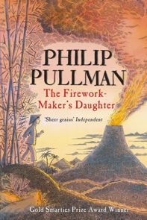  P. Pullman | Fiction
Year Four Reading Spine | The Last Bear  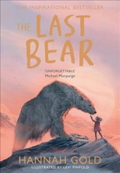  Hannah Gold | Fiction
 | Julius Caesar  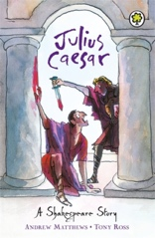  Shakespeare for Children | Play | Storytime  History link – Romans
 | The Dragon Machine  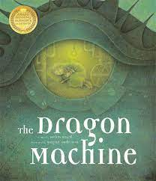  H. Ward | Fiction
 | 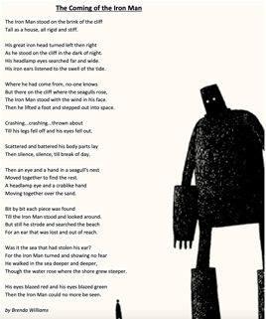 | Poetry
 | 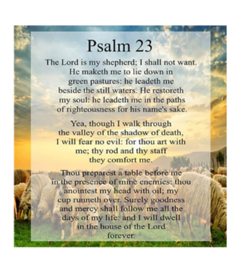 | Poetry
 | Julius Caeser  Shakespeare | Play
 | My name is not Refugee  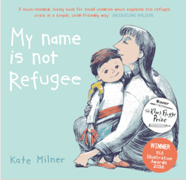 | Non-fiction
 | Migration  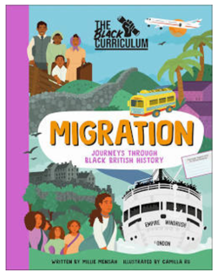 | Non-fiction
 | 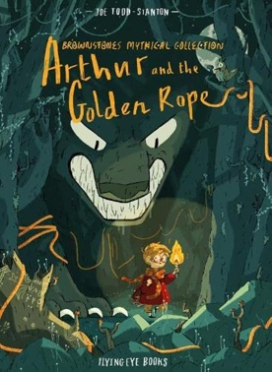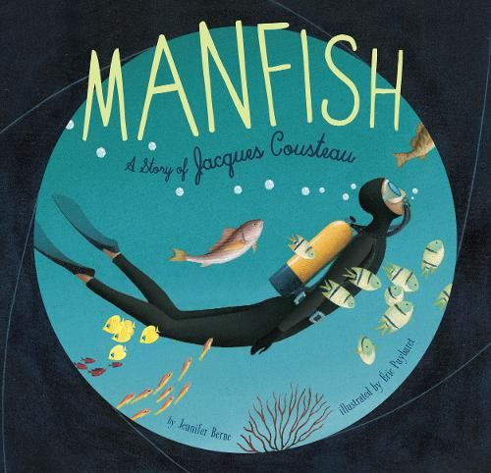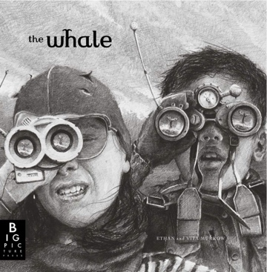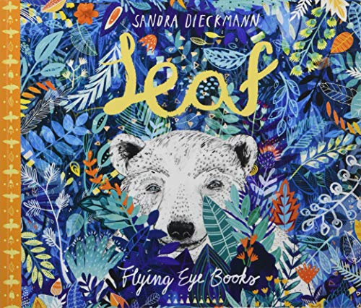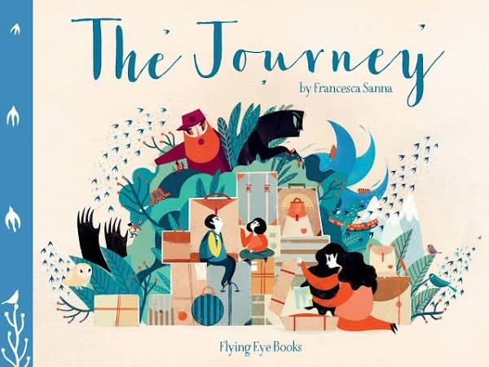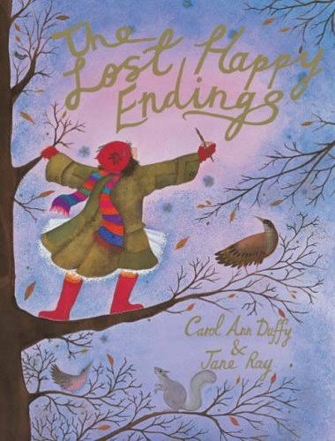
Along Came a Different
Dogs Don’t Do Ballet
Red: A Crayon’s Story
Aalfred and Aalbert
When Sadness Comes to Call
Julian is a Mermaid

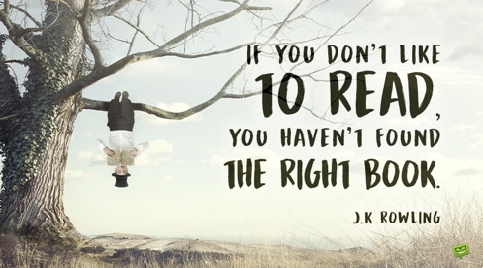

Year Five Reading Spine | Text | Genre | Purpose
Year Five Reading Spine | Journey to Jo’Burg  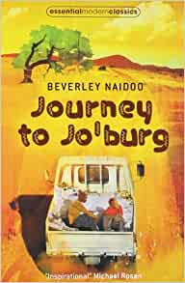  Beverley Naidoo | Stories from other Cultures  Modern Classic | Storytime
Year Five Reading Spine | I am the dreadful menace  Anon  In Flanders Fields  John McCrae  The Moon at Knowle Hill  Jackie Kay | Poetry
Year Five Reading Spine | Letters from the Lighthouse  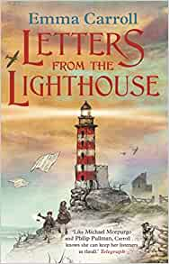  Emma Carroll | Historical Fiction | Storytime  WW2 link History
Year Five Reading Spine | The Boy at the Back of the Classroom  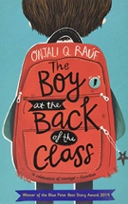  Onjali Q. Rauf | Fiction | Storytime  PSHE acceptance/identity  /bravery/ friendship & kindness
Year Five Reading Spine | The Cat Who Walked Across France  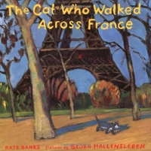  Kate Banks | Fiction Picture book | English unit - recount
Year Five Reading Spine | Archie’s War  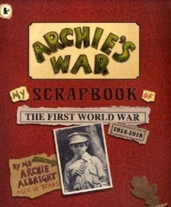  Marcia Williams | Historical fiction | English unit - recount
Year Five Reading Spine | The Highwayman  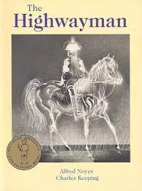  Alfred Noyes | Narrative poem | English poetry unit
Year Five Reading Spine | The Listeners  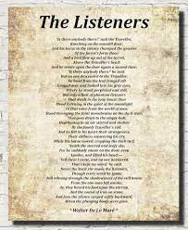  Walter de la Mare | Narrative poem | English poetry unit
Year Five Reading Spine | The Secret Garden  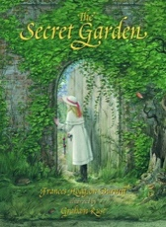  Frances Hodgson Burnett | Classic Fiction | Storytime
Year Five Reading Spine | Who Let the Gods Out  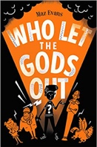  Maz Evans | Adventure | Storytime  History link Ancient Greeks
Year Five Reading Spine | Walking with my Iguana  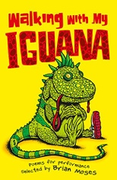  Brian Moses  My Dancing Gran  Brian Pattern  The Boneyard Rap  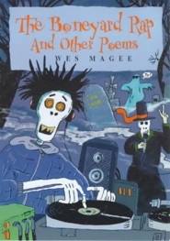  Wes Magee | Poetry | English Unit Poetry
Year Five Reading Spine | Shakespeare- The Animated Tales  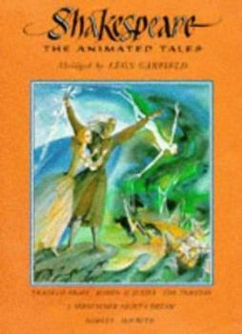  Leon Garfield | Classic Fiction | English unit
 | 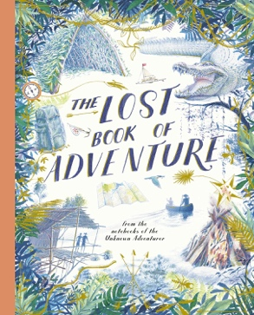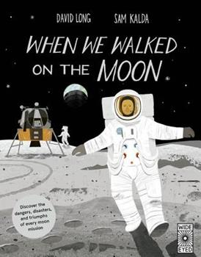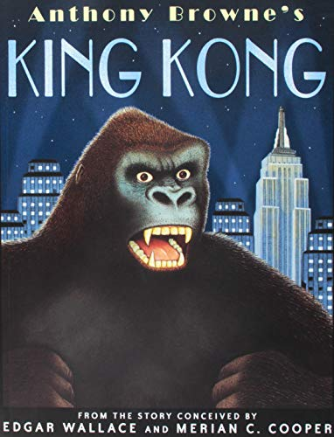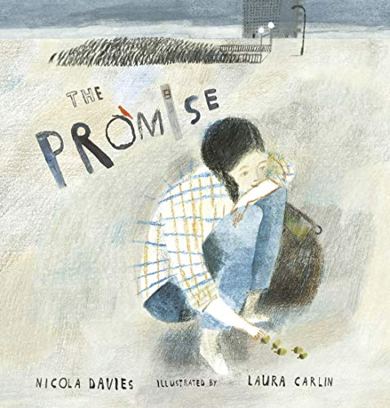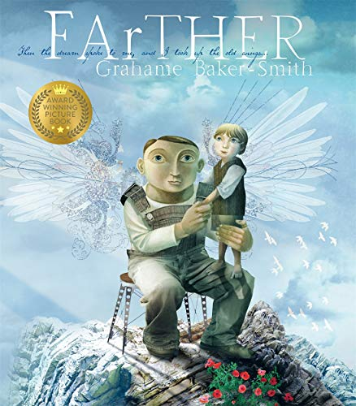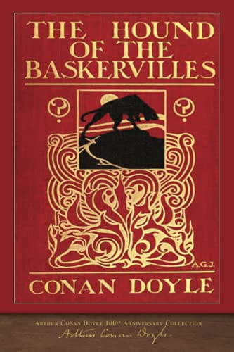
Kenny Lives with Erica and Martina
Rose Blanche
Mixed
How to Heal a Broken Wing
The Girls
And Tango Makes Three

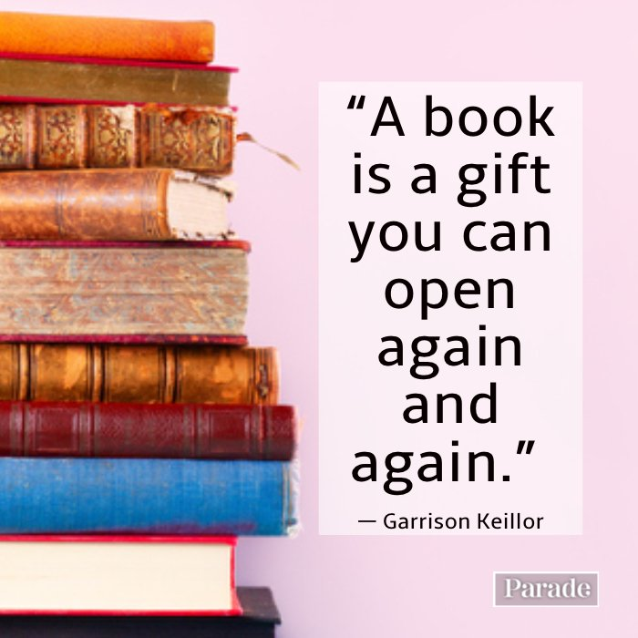

Year Six Reading Spine | Text | Genre | Purpose
Year Six Reading Spine | Wonder  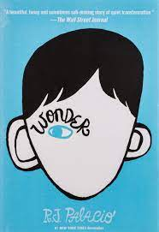  RJ Palacio | Modern Fiction | Storytime
Year Six Reading Spine | Kissing the Railings  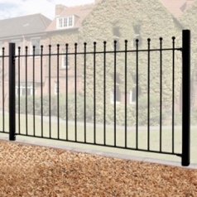  Pie Corbett | Fiction
Year Six Reading Spine | Drew  Headstart Y6  Clive Stack | Fiction | Whole Class Reading
Year Six Reading Spine | I Am Not a Label  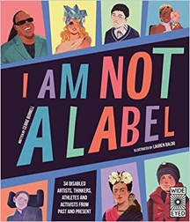  C. Burnell & L Mark Baldo | Fiction | Whole Class Reading
Year Six Reading Spine | From a Railway Carriage  R.L. Stevenson  A Poison Tree  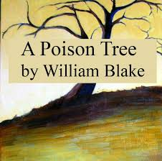  W. Blake | Classic Poetry | Whole Class Reading
Year Six Reading Spine | Peter Pan  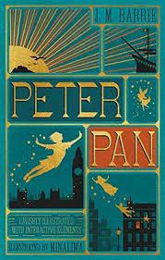  J.M. Barrie  Jane Eyre  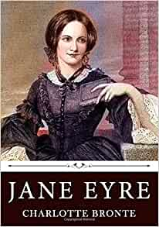  C. Bronte  Rebecca  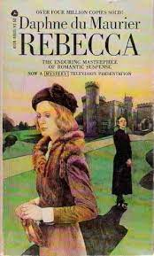  D. D. Maurier | Classic Fiction  Extracts | Whole Class Reading
Year Six Reading Spine | The Boy at the Back of the Class  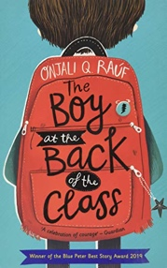  Onjali Rauf | Modern fiction | Storytime
Year Six Reading Spine | The Caravan  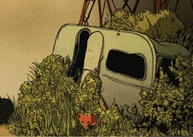  Pie Corbett | Fiction
Year Six Reading Spine | The War of the Worlds  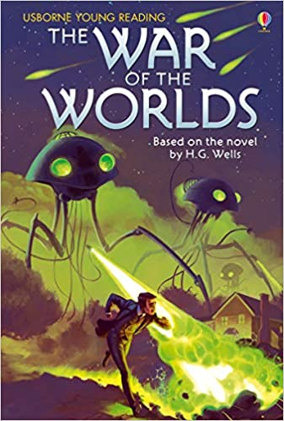  H. G Wells | Classic Fiction  Extracts | Whole Class Reading
Year Six Reading Spine | What on Earth  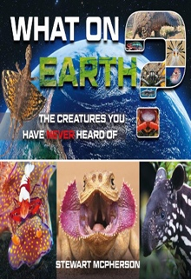  Stewart McPherson | Non-Fiction
Year Six Reading Spine | What a Waste: Rubbish, Recycling and Protecting our Planet  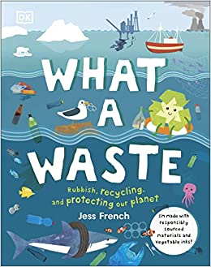  J. French | Non-Fiction | Whole Class Reading
Year Six Reading Spine | The Mosquito  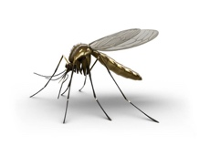  Ted Hughes  The Loner  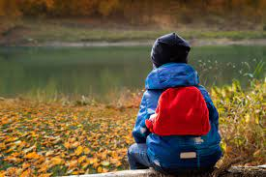  Julie Holder | Poetry | Whole Class Reading
Year Six Reading Spine | Boy  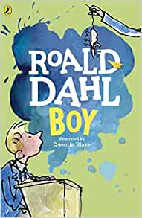  Roald Dahl  The Secret Garden  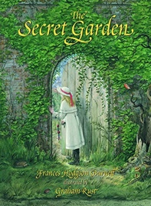  F. Hodgson  Huckleberry Finn  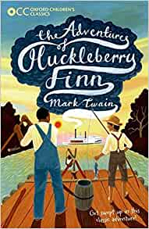  Mark Twain | Classic Fiction  Extracts | Whole Class Reading
Year Six Reading Spine | Happy Here  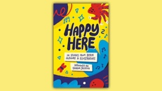 | Fiction | Storytime
Year Six Reading Spine | Just Like Me  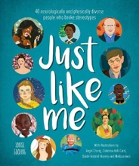  L. Gooding  Local Safari  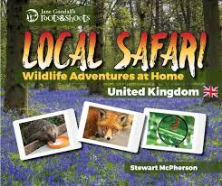  Stewart McPherson  Incredible Earth  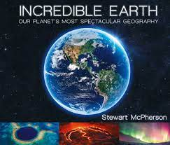  Stewart McPherson | Non-Fiction | Whole Class Reading
Year Six Reading Spine | The Sea  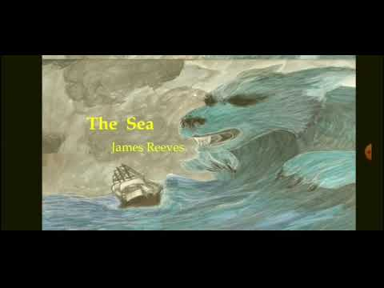  J. Reeves  The Raven  E. Allan Poe | Poetry
Year Six Reading Spine | Rainforest Song  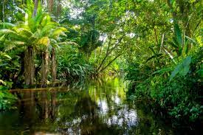  T. Mitton | Poetry | Whole Class Reading
Year Six Reading Spine | The Diary of Anne Frank  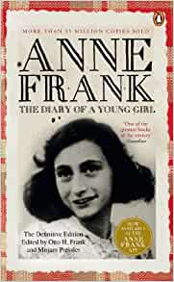  A. Frank | Autobiography  Diary | English Unit
 | Black Beauty  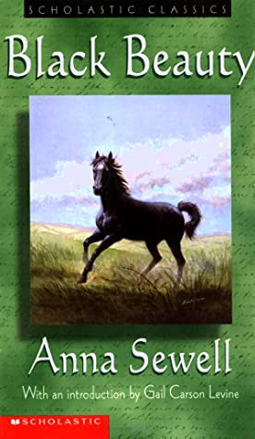  Anna Sewell  Treasure Island  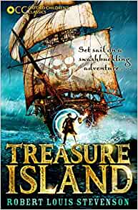  Robert Louis Stevenson  White Fang  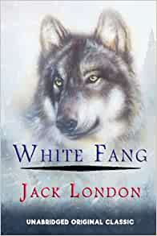  Jack London | Classic fiction Extracts | Whole Class Reading
 | 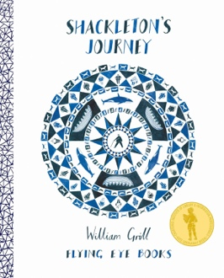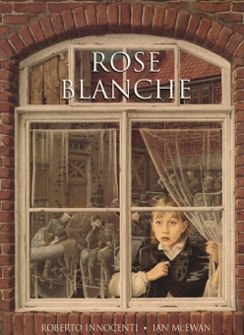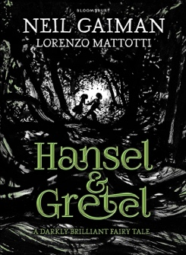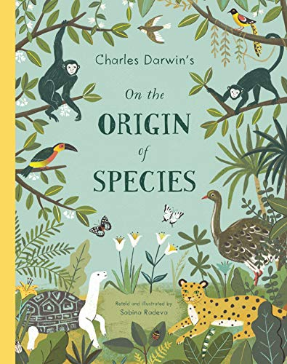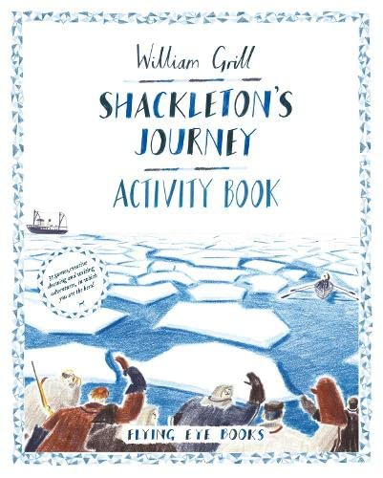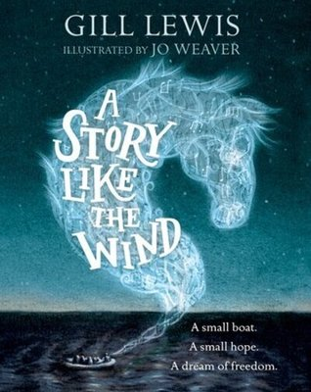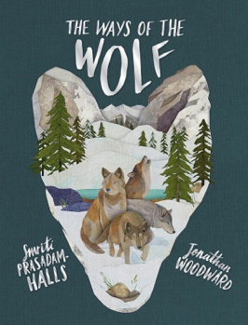
King of the Sky
The Only Way is Badger
Leaf
The Island
Introducing Teddy
A Day in the Life of Marion Bundo

Key:
Red | English units
Green | Storytime - pleasure
Blue | PSHE – diversity/ No Outsiders
Orange | Science/geography
Purple | Historical link

